**IMAGE ENHANCEMENT**

A PROJECT REPORT OF WEEK-01

(Literature Survey)

Submitted by

NEHA DEVIDAS MAHINDRAKAR (18BEC032)

NIKHIL S AMBIGAR (18BEC033)

NITHIN RANGINENI (18BEC034)

*in partial fulfillment for the award of Digital Signal Processing lab exam*

*of*

BACHELOR OF TECHNOLOGY

*in*

ELECTRONICS AND COMMUNICATION ENGINEERING



INDIAN INSTITUTE OF INFORMATION TECHNOLOGY

DHARWAD

AUGUST 2020/DECEMBER 2020

**Table of contents :**

|  |  |  |
| --- | --- | --- |
| **Sl no :** | **Topic** | **Page no** |
|  | What is Image Enhancement..? | 03-04 |
| 2) | Histogram processing | 05-14 |
| 3) | Logarithmic Transformations | 14-14 |
| 4) | Powers-Law Transformations | 15-15 |
| 5) | Homomorphic filtering | 16-18 |

**Image Enhancement :**

The aim of image enhancement is to improve the interpretability or perception of information in images for human viewers, or to provide `better' input for other automated image processing techniques.

Image enhancement techniques can be divided into two broad categories:

1. Spatial domain methods, which operate directly on pixels, and
2. Frequency domain methods, which operate on the Fourier transform of an image.

By the help of Image enhancement, we can remove noise, sharpen, or brighten an image, making it easier to identify key features.

Examples :

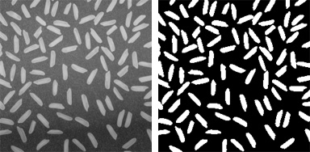 Before After

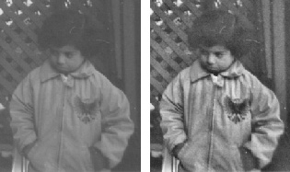BeforeAfter

Image enhancement algorithms include deblurring, filtering, and contrast methods

This report is designed by referring to following IEEE research papers and websites :

1. Image Enhancement in Spatial Domain(IEEE research paper) by Shanto Rahman, Institute of Information Technology, University of Dhaka, Bangladesh
2. Spatial domain Image Enhancement and restoration techniques by Kinita B Vandara, Dr. G.R.Kulkarni.
3. Image Enhancement Technique for Use in Real-Time Mobile Applications by Sergei Yelmanov Special Design Office of Television Systems Lviv, Ukraine
4. Mathematical Equations for Homomorphic Filtering in Frequency Domain: A Literature Survey by Sami A M(ICIM 2012)
5. Mathematical Equations for Homomorphic Filtering in Frequency
6. Domain
7. Mathematical Equations for Homomorphic Filtering in Frequency
8. Domain

**Spatial Domain Methods:**

In, Saptial domain techniques we directly deal with the image pixels. The pixel values are manipulated to achieve desired enhancement .Image Enhancement in the Spatial Domain is given by

g(x,y)=T[f(x,y)]

(, ) (, )gxy T f xy=

where f(x,y) is an original image, g(x,y) is an output and T[ ] is a function defined in the area around (x,y) Note: T[ ] may have one input as a pixel value at (x,y) only or multiple inputs as pixels in neighbors of (x,y) depending in each function.

**Histogram Processing :**

Histogram equalization (HE) is an important technique and is used in general for image enhancement. To enhance a given image, HE tries to spread the pixels intensity of that image based on the whole image information. As a result, there might be a case where some low intensity pixels are transformed with a high rate and create over-enhancement. Histogram equalization (HE) might also result in mean shift where mean brightness of an input image changes and thus might create undesirable artifacts. An improved version of HE is Brightness preserving **Bi-Histogram Equalization (BBHE)** which tries to overcome mean shift problem. BBHE transforms each pixel by separating the histogram based on the mean values of the image. Therefore, the mean remains fixed and over enhancement problem is reduced. This method firstly separates the histogram of an input image based on the mean brightness and then histogram equalization is applied on each part of the divided histogram. BBHE works well where the input image has symmetric distribution around its mean. However, it might fail for non-symmetric distribution. A similar algorithm of BBHE is **Dualistic Sub-Image Histogram Equalization (DSIHE)** where histogram separation is done based on median instead of mean. Though DSIHE does not allow significant mean shift in the output image, it also fails to preserve mean brightness in some cases. **Minimum Mean Brightness Error Bi-Histogram Equalization (MMBEBHE)** is an improved version of BBHE and DSIHE to preserve the mean brightness of the image. In MMBEBHE, histogram is separated according to the threshold level, where threshold level is calculated based on the **absolute mean brightness error (AMBE).** After separating the histogram based on AMBE, histogram equalization is applied on each of the divided part. Though this method enhances the contrast of an image suitably, sometimes it produces more annoying side effects.

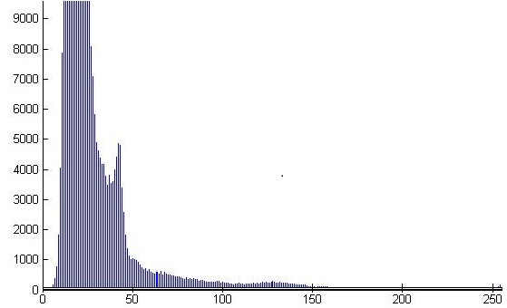

Original image Original image histogram

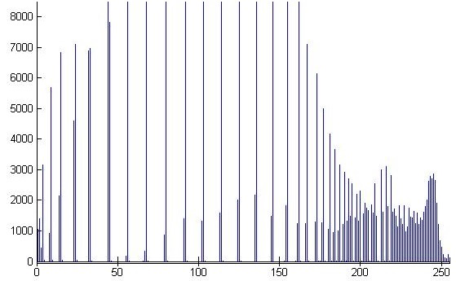 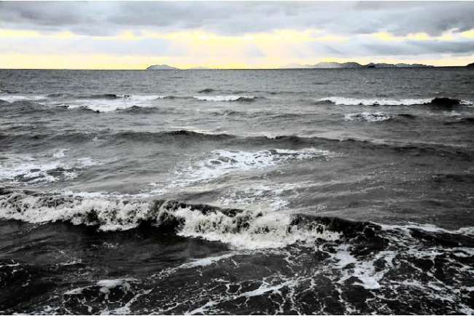

Histogram equalization HE Histogram

A combination of BBHE and DSIHE is **Recursively Separated and Weighted Histogram Equalization(RSWHE)** which comes for brightness preservation and to enhance the contrast of an image. Furthermore, a weighting histogram function is introduced to get a desirable histogram. The core idea of this algorithm is to break down a histogram into two or more portions and then apply a weighting function (based on a normalized power law function) for modifying the subhistograms. Finally, it performs histogram equalization on each of the weighted histogram. Histogram weighting module gives more probabilities to infrequent gray levels whereas traditional transformation function does not give more probabilities to the infrequent graylevels. However, some statistical information might lose after the histogram transformation and the desired enhancement may not be achieved. Inspired by the RSWHE method, authors of **Adaptive Gamma Correction with Weighting Distribution(AGCWD)** use gamma correction and luminance pixels probability distribution to enhance the brightness and preserve the available histogram information. The transformationof the gamma correction (TGC) is defined

Where, lmax is the maximum intensity, and l represents each pixels intensity of an input image and T(l) denotes each input pixel's transformed intensity. Here, a hybrid histogram modification (HM) method is proposed to combine the traditional gamma correction (TGC) and traditional histogram equalization (THE) methods. Though most of the cases this method enhances the brightness of the input image, it might not give satisfactory results when an input image has lack of bright pixels. Brightness Preserving Histogram Equalization with Maximum Entropy (BPHEME) preserves image brightness where authors create ideal histogram that maximizes the entropy. They want to preserve the brightness of an image as well as to increase the entropy of the image. Therefore, considering the mean brightness is fixed, BPHEME transforms original histogram to target histogram and then applies histogram specification (HS). As a result, over enhancement effect is reduced. Though this algorithm provides acceptable results for continues case, it fails for discrete ones. **Exact histogram specification (EHS)** is based on the strict ordering among image pixels. It uses local mean values for enhancement. Here, the histogram and the probability density function (PDF) of the image become uniform after enhancement. Moreover, EHS improves the contrast of an image by maximizing its entropy.

**Dynamic Histogram Specification (DHS)** preserves the shape of the input image histogram. Along with this, the method also increases the contrast effectively. DHS extracts local maxima using first and second derivatives. Moreover, these two are used to find the critical points (CP). Then direct current is calculated which is combined with the CP to find the specified histogram cumulative density function (CDF) and finally maps the input to the output. Though this algorithm preserves input image characteristics, images are not enhanced significantly.

In Conventional Piecewise Linear Transformation, there are few parameters which should be set manually. Furthermore, such setting may not work effectively for real life images. To mitigate these drawbacks Tsai et al proposed an **automatic and parameter free Piecewise Linear Transformation (APLT)** function for color images. Their major contribution is to generate automatic and parameter free piecewise linear transformation function. The locations of the luminance distribution valleys are used to set the input parameters and this distribution is also used to find the number of line segments. The output parameters are set by

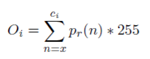

Here, Oi represents output parameters, pr(n) represents luminance probabilities of the distribution, x is the starting luminance of the histogram. In general most of the contrast enhancement methods fail to produce satisfactory results for color images such as dark, low-contrasted, bright, mostly dark, high-contrasted, and mostly bright images. Thus, Tsai et al. proposed a decision tree-based contrast enhancement algorithm, which is used to decide the type of input image whether it is dark, low-contrasted, bright, mostly dark, high-contrasted or mostly bright. After deciding the input image type, piecewise linear transformation is applied to enhance the image. This method performs well for skin detection, visual perception and image subtraction measurements.

Celik and Tjahjadi proposes **Contextual and Variational Contrast enhancement (CVC)** which is effective to create better visual quality output image. The contrast is increased here by using inter pixel contextual information. The mutual information of each pixel and its neighboring pixels are used to create a 2D histogram and the enhancement is performed by using a smoothed version of this histogram. For this, they map the diagonal elements of the input histogram to the diagonal elements of the target histogram. This algorithm produces comparatively better enhanced image. But the computational complexity of this method is high and become higher with the increment of differences among neighboring pixels. Global enhancement methods cannot always provide satisfactory results. For example, when there is a sudden peak in the input histogram, global enhancement methods does not work well. Layered Difference Representation (LDR) comes to overcome this problem. The authors claim that better enhancement can be achieved by using four neighbors. They first classify different gray levels into multiple layers, which are similar to a tree structure for deriving a transformation function. The transformation function can be determined by

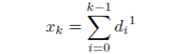

Here, di^1 is the difference of the intensities at layer 1 of the tree and xk represents the summation of all difference occurred in layer 1.After getting the transformation functions for each layer, all of those are aggregated to achieve the desired transformation function. Though LDR works with sudden peaks, it cannot perform accurately. Sudden peaks are more accurately handled using **histogram modication framework (HMF).** HMF depends on histogram equalization and contrast enhancement of an image. Besides, this method can handle noise and spikes of an image using black and white stretching with an optimization procedure. Different levels of contrast enhancement are used here along with several adaptive parameters. However, these parameters have to be manually tuned to achieve high level of contrast.

**Experimental Results:**

The experimental results produced by HE, EHS, HMF, LDR, CVC, RSWHE and AGCWD. To enhance the contrast as well as to preserve or enhance the brightness of an image, these methods are applied on various grayscale and color images. In this paper, we separate our experimental results into two sections:

(a) qualitative measurement

(b) quantitative assessment.

For qualitative measurement, we consider only visual assessment and for quantitative analysis we consider Peak Signal to Noise Ratio (PSNR), Normalized Cross-Correlation (NCC), Execution Time (ET) and Discrete Entropy (DE)

**Qualitative measurement:**

HE directly tries to equalize the original image histogram and loses some intensity information. Though some artifacts exist, output image can be clearly visualized because of the brightness increment. EHS performs a strict ordering among image pixels and histogram guarantees to maintain uniformity among the pixels. As a result, brightness and contrast are increased. Using black and white stretching HMF tries to mitigate the noise of an image such as sudden spikes. LDR separates image into several layers based on intensity results to preserve the brightness. The RSWHE makes some artifacts due to increase in the probability of infrequent pixels. AGCWD enhances the brightness of an image. As a result, output image is as equal as input image.

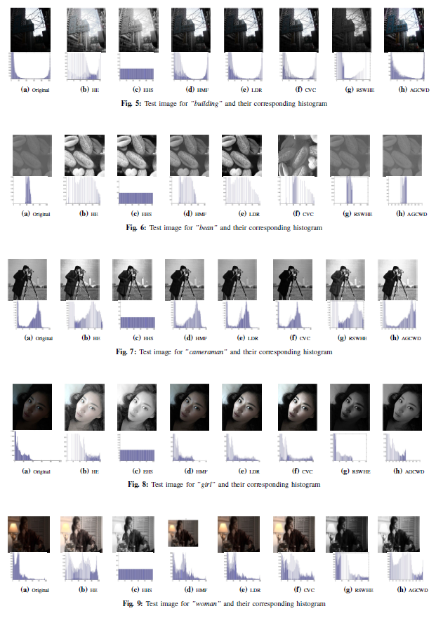

**Quantitative Evaluation:** Quantitative evaluation of image enhancement is not an easy task due to the acceptable criterion, we assess the performance of enhancement techniques using four quality metrics such as PSNR, NCC, ET and DE.

**Peak Signal-To-Noise Ratio:** Most of the cases the more the PSNR, the better visual quality of the image has. LDR has the highest PSNR in most of the cases. So, in this case the performance of LDR is best.

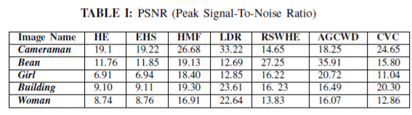

**Normalized Cross-Correlation:** Normalized cross correlation is used for measuring the difference between input and output image. From the Table II and Fig. 10(b), we can conclude that high difference exists in HE and EHS means that the rate of enhancement or changing is high in HE and EHS. As a result, HE produces high rate of artifacts which is also proved by qualitative assessment of the image.

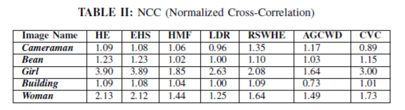

**Execution time:** The execution time is an essential metric in image processing due to have a strong correlation between time and quality. So, a tradeoff needs to determine between those. Table III presents execution time needed to run each algorithm. EHS needs lowest execution time. In this sense, EHS is the best technique among the described image enhancement methods.

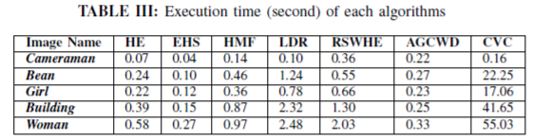

**Discrete Entropy:** Entropy is a measurement of uncertainty of a random variable. The more the variable is random, the more entropy an image has. Most of the cases EHS holds large entropy. So, in this case EHS also performs better than other if we give importance on the contrast of enhanced image.

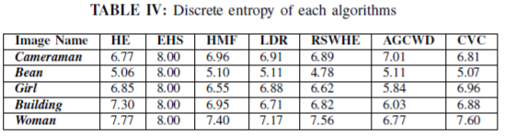

**CONCLUSION:**

A comparative study of image enhancement techniques, their advantages, limitations and application areas are presented here. The performance of image enhancement techniques is assessed by several evaluation metrics. Using PSNR metric we can conclude that LDR performs best. In Cross-Correlation, most of the cases HE have the highest level of enhancement that means HE has the maximum rate of deviation between the original and the enhanced image. CVC takes too long execution time than other enhancement techniques and finally in accordance with discrete entropy EHS has the highest value.

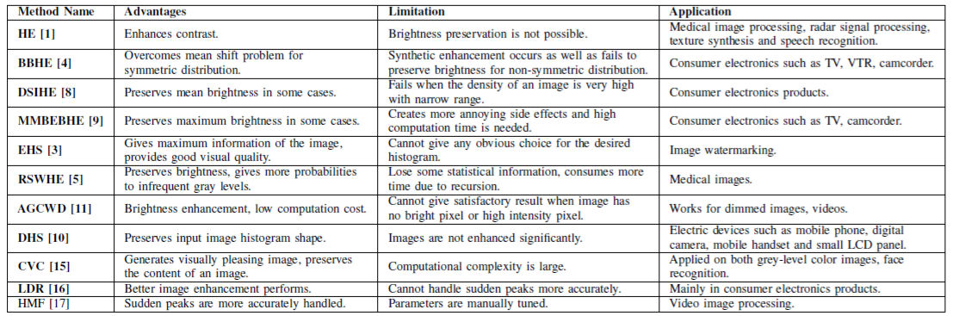Comparison of Contrast Enhancement Techniques

**Logarithmic Transformations:**

The general form of the log transformation is



The log transformation maps a narrow range of low input grey level values into a wider range of output values. The inverse log transformation performs the opposite transformation. Log functions are particularly useful when the input grey level values may have an extremely large range of values. In the following example the Fourier transform of an image is put through a log transform to reveal more detail.

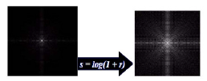

*Effect of logarithmic transformations*

**Powers-Law Transformations:**

The nth power and nth root curves are given by the expression ,



This transformation function is also called as gamma correction. For various values of different levels of enhancements can be obtained. This technique is quite commonly called as Gamma Correction. If you notice, different display monitors display images at different intensities and clarity. That means, every monitor has built-in gamma correction in it with certain gamma ranges and so a good monitor automatically corrects all the images displayed on it for the best contrast to give user the best experience. The difference between the log transformation function and the power-law functions is that using the power-law function a family of possible transformation curves can be obtained just by varying the lamda. These are the basic image enhancement functions for grey scale images that can be applied easily for any type of image for better contrast and highlighting. Using the image negation formula given above, it is not necessary for the results to be mapped into the grey scale range [0, L-1]. Output of L-1-r automatically falls in the range of [0, L-1]. But for the Log and Power-Law transformations resulting values are often quite distinctive, depending upon control parameters like and logarithmic scales. So the results of these values should be mapped back to the grey scale range to get a meaningful output image. For example, Log function s = c log (1 + r) results in 0 and 2.41 for r varying between 0 and 255, keeping c=1. So, the range [0, 2.41] should be mapped to [0, L-1] for getting a meaningful image.

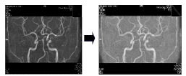

*Power-Law transformations*

**Frequency domain:**

In frequency domain method, the image is first transferred into frequency domain. It means fourier transform of the image is computed first. All the enhancement operations are performed on the fourier transform of the image and then the inverse fourier transform is performed to get the resultant image.

**Homomorphic filtering :**

One of the popular methods used to enhance or restore the degraded images by uneven illumination is by using homomorphic filtering. This technique uses illumination-reflectance model in its operation. This model consider the image is been characterized by two primary components. The first component is the amount of source illumination incident on the scene being viewed i(x,y). The second component is the reflectance component of the objects on the scene r(x,y). The image f(x,y) is then defined as



In this model, the intensity of i(x,y) changes slower than r(x,y). Therefore, i(x,y) is considered to have more low frequency components than r(x,y). Using this fact, homomorphic filtering technique aims to reduce the significance of i(x,y) by reducing the low frequency components of the image. This can be achieved by

executing the filtering process in frequency domain. In order to process an image in frequency domain, the image need first to be transformed from spatial domain to frequency domain. This can be done by using transformation functions, such as Fourier transform. However, before the transformation is taking place, logarithm function has been used to change the multiplication operation of r(x,y) with i(x,y) in (above equation) into addition operation.

In general, homomorphic filtering can be implemented using five stages, as stated as follows:

STAGE 1: Take a natural logarithm of both sides to decouple i(x,y) and r(x,y) components



STAGE 2: Use the Fourier transform to transform the image into frequency domain:

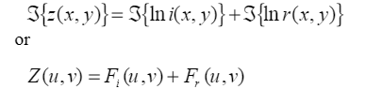

where Fi(u,v) and Fr(u,v) are the Fourier transforms of lni(x,y) and lnr(x,y)

respectively.

STAGE 3: High pass the Z(u,v) by means of a filter function H(u,v) in frequency domain, and get a filtered version S(u,v) as the following:



STAGE 4: Take an inverse Fourier transform to get the filtered image in the spatial domain:



STAGE 5: The filtered enhanced image g(x,y) can be obtained by using the following equations:



**Homomorphic Filtering equations:**

The typical filter for homomorphic filtering process has been introduced in stages 1-5. This filter has circularly symmetric curve shape, centred at (u,v)=(0,0) coordinates in frequency domain. This filter is modified from Gaussian highpass filter, which is known as Difference of Gaussian (DoG) filter. The transfer function for DoG filter is defined as:

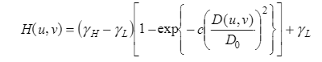

where constant c has been introduced to control the steepness of the slope, D0 is the cut-off frequency, D(u,v) is the distance between coordinates (u,v) and the centre of frequency at (0,0). For this filter, three important parameters are needed to be set by the user. They are the high frequency gain γh and the cut-off frequency D0. If γh is set greater than 1 and γl is set lesser than 1,then the filter function decrease the contribution made by the illumination (which occupies mostly the low frequency components) and amplify the contribution made by the reflectance (which occupies most of the high frequency components). At the end, the net result will be a simultaneous dynamic range compression and contrast

enhancement. The value of the low frequency gain should be set such as

γl =0.5 to halve the spectral energy of the illumination, and the value of high frequency gain is set such as γh=2 to double the spectral energy of the reflectance components.

The value of c is suggested to be equal to 0.5. In practice, all these three parameter values are often determined empirically and there is no clear way to choose the exact suitable values for these parameters.

These are the another two equations of homomorphic filtering:

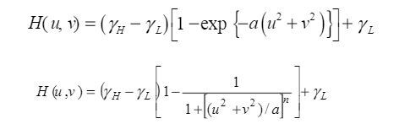

Above equation is the Gaussian high-pass filter, and below is the modified Butterworth high-pass filter. In Butterworth high-pass filter, the term [((u*2)+(v*2))/a] determines the transition point and Butterworth power coefficient n determines the steepness of the transition slope. Empirically, when applying the homomorphic filtering process onto different types of image, the author found that a maximal amplification value (γh- γl)>=1.5 is too much for many images. Furthermore, the author also found that the modified high-pass Butterworth equation is better than Gaussian high-pass filter for the use in homomorphic filtering process because it allows an independent setting of the transition point from the transition slope.

*Thank you!!*